Table of Contents

Introduction 1

Overview Training Package 1

Why Adaptive Gaming? 2

Rehabilitation 2

Game Development 2

Thank You 2

ABC & MMC 3

MMC Contact 3

Gaming Specialist: 3

Joining the GAME Checkpoints Discord 4

The information contained in these documents and any DIY AT devices are subject to the Makers Making Change Terms of Use which can be found at: <https://makersmakingchange.com/terms-of-use/>

Attribution

Makers Making Change wants to recognize and thank the following organizations for contributing to these resources by working directly with us and/or sharing your resources online. You are the communities making gaming possible for so many and allowing people to play the way they want to.

* The AbleGamers Charity
* SpecialEffect
* Readapted Gaming

A special thank you to the Game Changers team at the Stan Cassidy Centre for Rehabilitation for working with us to test and give feedback on the GAME Checkpoints program/training.



Version 1.0 of the GAME Checkpoint Resource Guide package was created by:

Tyler Fentie

&

Josie Versloot

# Introduction

## Overview Training Package

Welcome to the GAME Checkpoints Reference Guide. The content in this document is intended to give guidance on the gaming gear provided through the MMC GAME Checkpoints initiative, give an overview of the gaming world, share helpful resources/compatibility tables, and provide tips and tricks relating to adaptive gaming.

This reference guide is broken into 5 main sections with following appendices. Note that the other sections will be the same across the various centers. Therefore, there may be information there that is not relevant to your particular adaptive gaming journey but may be useful in the future. The 5 sections and their general purpose are below:

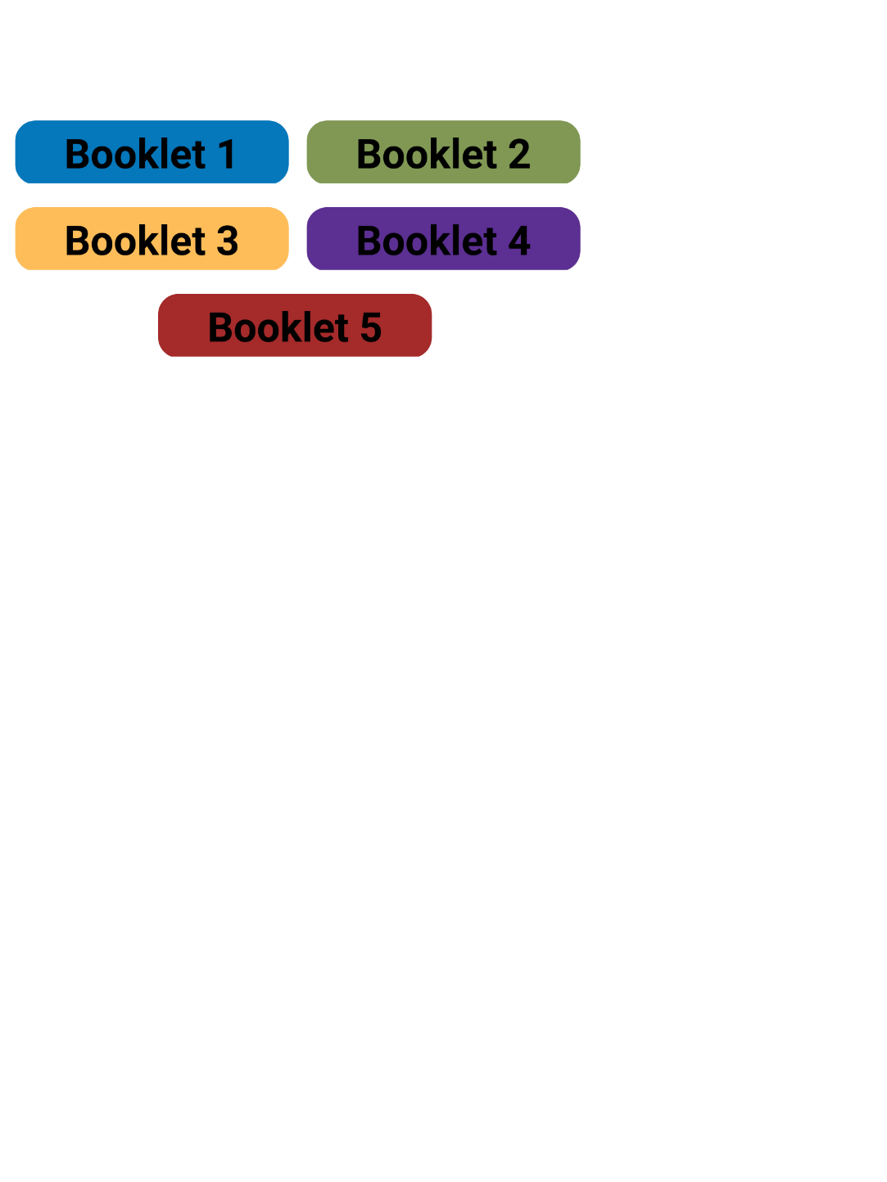

1. **Booklet 1 - Introduction**
   * Overview of what is possible in adaptive gaming and why it is important.
   * Information on the MMC community around you and how to get support.
2. **Booklet 2 - Gaming Gear**
   * Breakdown of the gaming devices and assistive technology that is used in adaptive gaming.
   * Describe compatibility and use cases of the devices.
3. **Booklet 3 - Gaming Basics**
   * Breakdown of the gaming world and education of gaming culture.
   * Discussion of the variety of experiences players can have.
   * Accessibility in video games and how to navigate those features.
4. **Booklet 4 - Game Training**
   * Summary of the key aspects of the 10 games that were supplied by the MMC team.
   * Quick reference of the accessibility features and playstyles of the games.
5. **Booklet 5 - Best Practices**
   * Overview of the potential process your organization may use with a gamer visiting your space.
   * Summary of the tips and tricks when creating adaptive gaming set up.

## Why Adaptive Gaming?

Gaming is fun! Gaming is a wide, inclusive, continuously developing community that provides the opportunity to meet new people and have unique experiences. People living with disabilities report significantly higher rates of social isolation. Utilizing gaming in anyone’s personal life can open possibilities for greater connection. It is not required to play games with others to make this connection either; even enjoying one specific game or genre can result in getting involved with a supportive fanbase. Gaming setups that require specialized devices or customization can be costly when often times if someone is completely new to gaming they will need a system, games, assistive tech, and getting this all right on the first try is nearly impossible. Utilizing open source assistive technology (AT) and trying out setups in the community can lessen the cost burdens and get more gamers going. The gaming is for everyone, no matter who you are or how you game. Whether you are new to the space or a returning gamer whose gaming may need some adaptations to effectively game, there are solutions available.

### Rehabilitation

Adaptive gaming is also a very powerful tool in rehabilitation. Gamifying switch access, voice controls, or any other tool that can be used for access can result in much higher acceptance rates of the technology. Adaptive gaming can also provide independence when accessing digital content. The [Craig Hospital](https://craighospital.org/blog/benefits-of-adaptive-gaming-in-neuro-rehab#:~:text=Motor%20Control%2FMovement%3A%20Using%20adaptive,patients%20build%20strength%20over%20time.) is a leader in using games in rehabilitation settings for gamers with physical and or cognitive disabilities to benefit things such as motor control, balance, attention, pain management, and more.

### Game Development

There have been significant strides in recent years to make accessibility a priority in game development. Many developers of mainstream and independent games have included more accessibility options and review their game design from an accessibility perspective. More and more developers are working to create games with a wholistic perspective of accessible designing which is further expanding the ability for people to participate in the world largest entertainment industry. The game industry has grown to be worth over $176 Billion, surpassing all of the traditional entertainment industries.

### Thank You

In summary, thank you for being apart of the journey to make the gaming space more accessible to a larger population of gamers. Your efforts and participation will mean more people will be able to engage with the growing gaming community and reduce the barriers to allow people the right to access the communities, content, and experiences they want. We appreciate your partnership to help Neil Squire Society’s mission to empower Canadians with disabilities.

# ABC & MMC

Welcome to the Makers Making Change (MMC) community! Makers Making Change is part of the Neil Squire Society that is a Canadian national non-profit. Makers Making Change leverages community based makers, disability professionals, and volunteers to help develop and deliver affordable open source assistive technologies.

We have three regional coordinators for west, central, and Atlantic provinces who facilitate the fantastic work that local volunteer Makers and Chapters provide. Information to contact the regional coordinator of your region can be found in the “Contact” section below.

Some volunteers or centers are extraordinary leaders in our community and take on the role of MMC Chapters and Super Makers in your area. These folks will be introduced to you and are willing to volunteer their time to help support your endeavor. MMC has Chapters across North America, a full list can be found on our community tab on our website. Chapters and Makers come from all backgrounds and skillsets. Utilizing the community can be a powerful way to further your organizations goals in the adaptive gaming space. Below is a photo of chapters near you, use this link if you want to see the full list.

*Photo*

|  |  |  |
| --- | --- | --- |
| **Maker** | **Skillset** | **Contact** |
| John Smith EXAMPLE | * 3D Printing * Soldering * Involved with Childrens Hostpital | [Alksdjfljasdlfjj@gmail.com](mailto:Alksdjfljasdlfjj@gmail.com)  780-555-7367 |

## MMC Contact

Below is the information for the regional coordinators and head office. The section in bold is the regional coordinator overseeing your area.

|  |  |
| --- | --- |
| **Shanelle Waiting**  **Regional Coordinator, (Western Region)**  [**Shanellew@neilsquire.ca**](mailto:Shanellew@neilsquire.ca) | Courtney Cameron  Regional Coordinator, (Eastern Region)  [courtneyc@neilsquire.ca](mailto:cournteyc@neilsquire.ca) |
| Suzanne Winterflood  Regional Coordinator, (Central Region)  [suzannew@neilsquire.ca](mailto:suzannew@neilsquire.ca) | Head Office (Burnaby, BC)  [Info@makersmakingchange.com](mailto:Info@makersmakingchange.com)  604.473.9363  1.877.673.4636 (TOLL FREE) |

### Gaming Specialist:

Tyler Fentie (he/him)

[tylerf@neilsquire.ca](mailto:tylerf@neilsquire.ca)

## Joining the GAME Checkpoints Discord

This Discord Server is an online platform that is intended to connect all of the GAME Checkpoints together for the purpose of sharing gaming related information, troubleshooting questions, or for potential future gaming events. In addition, utilizing and getting familiarized with platforms that gamers use, such as discord, will help provide more informed assistance to your community.

**Each center will get a personal invite to the Discord via email.**